Win-win Exchange and Cooperation

Organizer: Admissions Information Network of China
Co-sponsors: Taiyuan Educational Television station, Shanxi Evening News,
Find a School Magazine; 533 Study Abroad Network,
Find Schools Navigation Network, Global Education Network;
hosted by: Taiyuan Yuanqi Advertising Co.
Supported by:
Education Alliance Marketing Organization,
Taiyuan, the annual selection committee of education
Shanxi Branch of Bank of China,
Shanxi Branch of bank of communications
Everbright Bank branches in Taiyuan,Taiyuan Branch of HSBC;
Official Website: www.zxxdh.com
Tour time and place:
March 30, 2013 Taiyuan Yingze Hotel (Yingze Street, No. 189)
March 31, 2013 Linfen Fushilong Hotel (South Pingyang Street, No. 104)
March 31, 2013 Datong Hongan Guobin Hotel (West Yingbing street,No.28)

As the world recognized one of the main source of foreign students, China has became the target which the institutions in the world's major countries are competing to attract outstanding students. According to the Ministry of Education statistics shows that, Growth in the number of studying abroad increased by 25% in 2011 compared with2010.the number of students expected this year, nearly 30 million. Number of students are nearly 300 thousands this year.Student academic competition is fierce every year and the exchange of information between students and schools aren’t asymmetry make the students no satisfied.
"International Education Exhibition" is for students to clear up doubts, accurate positioning of the golden season,also the best time of students to choose school.
With the International Education Fair ,students can meet face to face with the institutions, which is Very convenient for schools and students ,also is best opportunity to establish the image and enhance visibility,recruit new students.
Yingze Hotel summary: located in the Yingze area, Yingze street, No. 189 ,have 291 rooms.It is the reception unit of four groups of Shanxi Province and provincial organs. "the best four-star hotel", "provincial civilized unit model." It has been visited by many famous people of all part of the worlds, people as follow:Liu Shaoqi, Zhu De, Peng Zhen, He Long, Chen Yi, Li, Wen Jiabao, Li Changchun and other party and state leaders, former U.S. Vice President Quayle, former German Chancellor Gerhard Schroeder and other foreign heads of state and Montgomery Marshal, Guo, Mei Lanfang, Anna Chennault, Shaw, Terry Gou, Yao Ming, Richard • Clayderman and other celebrities in 50 years. Hotel is located in the central business district of Taiyuan. adjacent to the Willow Lane downtown,across to the Yingze Lake, Ideally located minutes away.

First, Expo features:
This exhibition will show the four main themes, Grouped visits consulting area, dock area of international education programs,market analysis will study, to analyze the investment immigration.
1, visit to consult the District
Meeting time and place:
March 30, 2013, Taiyuan (Yingze Hotel),
March 30, 2013, Linfen (Fushilong Hotel)
March 30, 2013, Datong Hongan (Guobin Hotel)
Consultation with the District set to visit 160 booths, according to continents and countries showcase for the school and students face to face.
2, the international education project matchmaking
Meeting time and place:
March 30, 2013, Taiyuan (Yingze Hotel),
March 30, 2013, Linfen (Fushilong Hotel)
March 30, 2013, Datong Hongan (Guobin Hotel)
Meeting time: first: 9:00 - 9:30; second :9:40-10: 10;
Third :10:20-10: 50; fourth :11:00-11: 30; fifth :11:40-12: 10;
Project Matchmaking Symposium: well-known institutions, education programs
Guests: Invited the leadership of the province related to the education system, the majoruniversities, colleges, focusing on secondary schools, foreign language training and many other responsible person to attend the international education
project matchmaking.
Matchmaking site settings"card wall" "project recommended consulting seats",
ashonored guests to provide adequate opportunities for exchanges and cooperation.

3, the market analysis to study abroad
Market analysis to study abroad will be designed with the needs of overseas students studying on-site analysis of the mainstream of the country of destination policy, Senior expert Will analyze the shortcut to elite school, how to choose schools and professional, students how to develop career planning and overseas students need to pay attention.

Meeting time and place:
March 30, 2013, Taiyuan (Yingze Hotel),
March 30, 2013 Linfen (Fushilong Hotel)
March 30, 2013 Datong Hongan (Guobin Hotel)
The first 9:00 am-9: 30 Subject: U.S. study
Second :9:40-10: 10 Topic: UK study
Third :10:20-10:50 Subject: Canadian study
Fourth :11:00-11: 30 Subject: Study in Australia
Fifth :11:40-12: 10 Subject: Germany and other
Participants: with the intention to go abroad for students and parents
4, Explain the full range of investment immigration countries
Explain the full range of investment immigration countries –
Authoritative interpretation, depth of analysis;
Meeting time and place:
March 30, 2013, Taiyuan (Yingze Hotel),
March 30, 2013 Linfen (Fushilong Hotel)
March 30, 2013 Datong Hongan (Guobin Hotel)
Meeting Time: first: 9:00 am-930; second :9:40-10: 10;
third :10:20-10: 50; fourth :11:00-11: 30; fifth :11:40-12: 10;
form: Topic Lecture + Q & A site;
Participants: with investment, immigration needs of families and business people;

Second, the exhibition publicity
- the Official website of this International Education Fair is "to find schools
navigation",It Opened up the International Education Expo Channel on the website. (With: study abroad, immigration, the world's elite, embassies, foreign languagetraining and other relevant authoritative information).
- This exhibition at the Shanxi Evening News, Taiyuan educational television station,TV station and many other media Datong great publicity and news coverage.
- "International Education Exhibition" journal: Current printing 50000, on March 18- March 29 for all secondary schools in Shanxi Province, universities, immigration hall, banks, hotels, shopping malls,upscale communities, free of charge, reserve 5000 journal surface to IELTS,
TOEFL test centers precise release (twice a month IELTS, TOEFL, each about 400 the number of exams).
- International Education Fair Free admission tickets: Printing 3 000 000, on March 9 -
March 29 for the province in all secondary schools, university students free of charge, as a complement international education exhibition publicity.
- Before the event, Committee will present "International Education International Education Exhibition and project matchmaking" service-related posters
and tickets for all secondary schools, universities and other education-related
organizations, schools will bean nounced this way each student and parents. Educational institutions also invited to attend the relevant person in charge of international education project matchmaking.
The current "International Education Exhibition" organized by the powerful media anda number of media focus on joint activities on-site, in the "Admissions Information Network China" open up "International Education Exhibition" channel, reported netSync, live coverage of the three interactions, the formation of three-dimensional information pattern.

Third, Media

Print Media: Shanxi Evening News, Sanjin City News, Shanxi Radio and Television News, Evening Datong News, Xinzhou Evening News, Changzhi Daily, Yuncheng Daily and other media.


TV: Taiyuan Educational TV, Datong station, study the world channel,
Shanxi TV, Yellow River TV, Taiyuan TV, Shuozhou TV, Xinzhou TV,
Changzhi TV, Yuncheng TV.
.

Network Media: 533 study abroad network, global education network,
find schools navigation network, Mayflower abroad Forum,
Shanxi China News Agency, Shanxi Xinhua News Agency, Shanxi candidates,
Sina education, Tencent education, international education online,
easily accessible to study, go abroad study network.



Fourth, the exhibition details
1 Booth Reservations: The section to the subject, exhibitors Deadline February 28;
2 show time and place: March 30, 2013, Taiyuan (Yingze Hotel),
March 30, 2013 Linfen (Fushilong Hotel)
March 30, 2013 Datong Hongan (Guobin Hotel)
3 Reception Hours: March 29, 2013, 9:30am -16:30 pm
4 Reception Place: Yingze hotel (Taiyuan, Shanxi Province), West
Education Fair Organizing Committee reception
5 Reception the reception line: 13073585898 13073585868 Customer service 4000-227-114
6 Booth Description: The name of exhibitor booth made ​​by the Organizing Committee; booth size is 2m * 2m,exhibitors are free to Design background(up to 3),
banner stand, roll up and other promotional materials.
7 Itinerary: at 3 pm the day of the show, united in the hotel
courtyard Yingze Datong by bus to go to the venue to stay (all Process 4 hours)
Note: Taiyuan to Datong transportation arranged by the Organizing Committee, Accommodation themselves (Organizing Committee can assist the client to book in advance or more recommended for customers to choose the hotel)

Fifth, value-added services
1 VIP Exclusive: Which to participate in the "International Education Exhibition "exhibitors, get "Navigation to find a school network, " the official VIP customer channel one month;
2 "think tank" experts Platform: All participants in this "International Education Exhibition" exhibitors, get "Navigation to find a school network" study guide experts "think tank" platform, click on the network can communicate directly with students.
3 the lifetime membership: which participate in the "International Education Exhibition" exhibitors will be eligible for free registration "to find schools navigation network" study area members enjoy lifetime membership services.
4 "study published show" precise information: for IELTS, TOEFL test centers precise release promotional materials (twice a month, take the exam each time the number of 400 or so).

Sixth，Registration form

Please fill out the form and receipt together with the remittance certificate by fax to 86-351-8339205
Name of School  (Chinese) |  |  |  |  |  |  |  | Web  site
Name of School  (English) |  |  |  |  |  |  |  | Phone
Exhibitors  (address) |  |  |  |  |  |  |  | Fax
Responsible people | Name |  |  |  | Participants | Name  Phone |  | Official seal：  Managers：  Date：
Responsible people | Duties |  |  |  | Participants
Responsible people | Mobile |  |  |  | Participants
Responsible people | Q Q |  |  |  | Participants
Responsible people | MSN |  |  |  | Participants
First，Booth fee (yuan) Please use the "√" election package
Package 1: Taiyuan Booth 4800 + Datong Booth 4000 +Linfen Booth 4000+colorjournal 4800 = 15,800 yuan □
Package 2(South Line): Taiyuan Booth 4800 + Linfen Booth 4000 +colorjournal 4800 = 13,000 yuan □
Package3(North Line): Taiyuan Booth 4800 +Datong 4000 + colorjournal 4800 = 13,000 yuan □
Package4 Taiyuan educational television(Recruitment, study weathervane column 90 seconds thematic) Offer 18000 Price 3000 yuan / time
Broadcast time Monday to Thursday "Recruitment" ，Friday and Saturday "Studying wind vane" , Premiere 20:40 replay 11:35 □
Second, on-site seminar (RMB), please use the "digital" option package
Taiyuan  (the main venue) | International Education Project Matchmaking Symposium 4800yuan/field □field | Datong  Linfen | Market annalysis study 3,000 yuan/field □field  Analysis will be 3,000 yuan investment immigration/Field  □field
Taiyuan  (the main venue) | Market annalysis study 3,500 yuan/field □field | Datong  Linfen
Taiyuan  (the main venue) | Analysis will be 3,500 yuan investment immigration/Field  □field | Datong  Linfen
Screenings:First: 9:00-9:30；Second:9:40-10:10；Third:10:20-10:50；Fourth:11:00-11:30；Fifth:11:40-12:10

Third, the journal (print 50000) |  |  |  |  |  | Four tickets (printed 3, 000 000)  50 000 from India
Version of the surface |  | Specification |  | Price  (yuan) |  | Version of the surface | Specific-ation |  | Quantity |  | Price  (yuan)
Color  version |  | 210 x 140mm |  | 5800 □ |  | The back | 210 x 90mm |  | 50000 pieces |  | 6800 □
Black and white  version |  | 210 x 140mm |  | 3800 □ |  | The back |  |  | 100000  pieces |  | 12000 □
Fifth, remittances (booking participants, the need to transfer to the following costs associated with account)
Account | Bank:民生银行太原桃园南路支行  Username:太原源启广告有限公司  Account No.0912014170014009 |  |  |  |  | Amount of remittance  RMB yuan（Lower case）  RMB yuan（Capital）
Date of remittance |  |  |  |  |  | Invoice payable
Six, accommodation (participants need help booking accommodation, see theofficial website: www.zxxdh.com)
Sponsor:太原源启广告有限公司
Customer Service 4000-227-114 FAX：0351 - 8339205
MSN：zxxdh.com@msn.cn Q Q:425018491 （Stamp）
Year Month Day

Taiyuan, the main exhibition hall bitmap
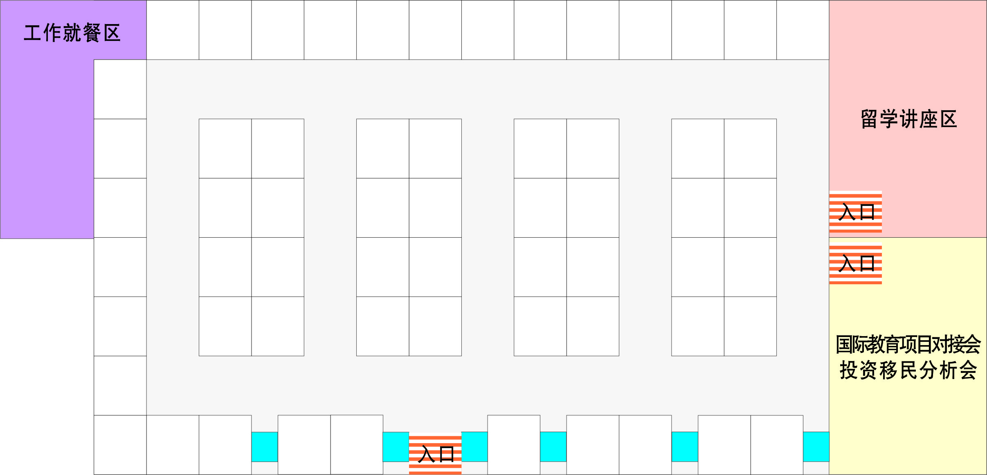
Datong Guobin Hotel(Booth map)
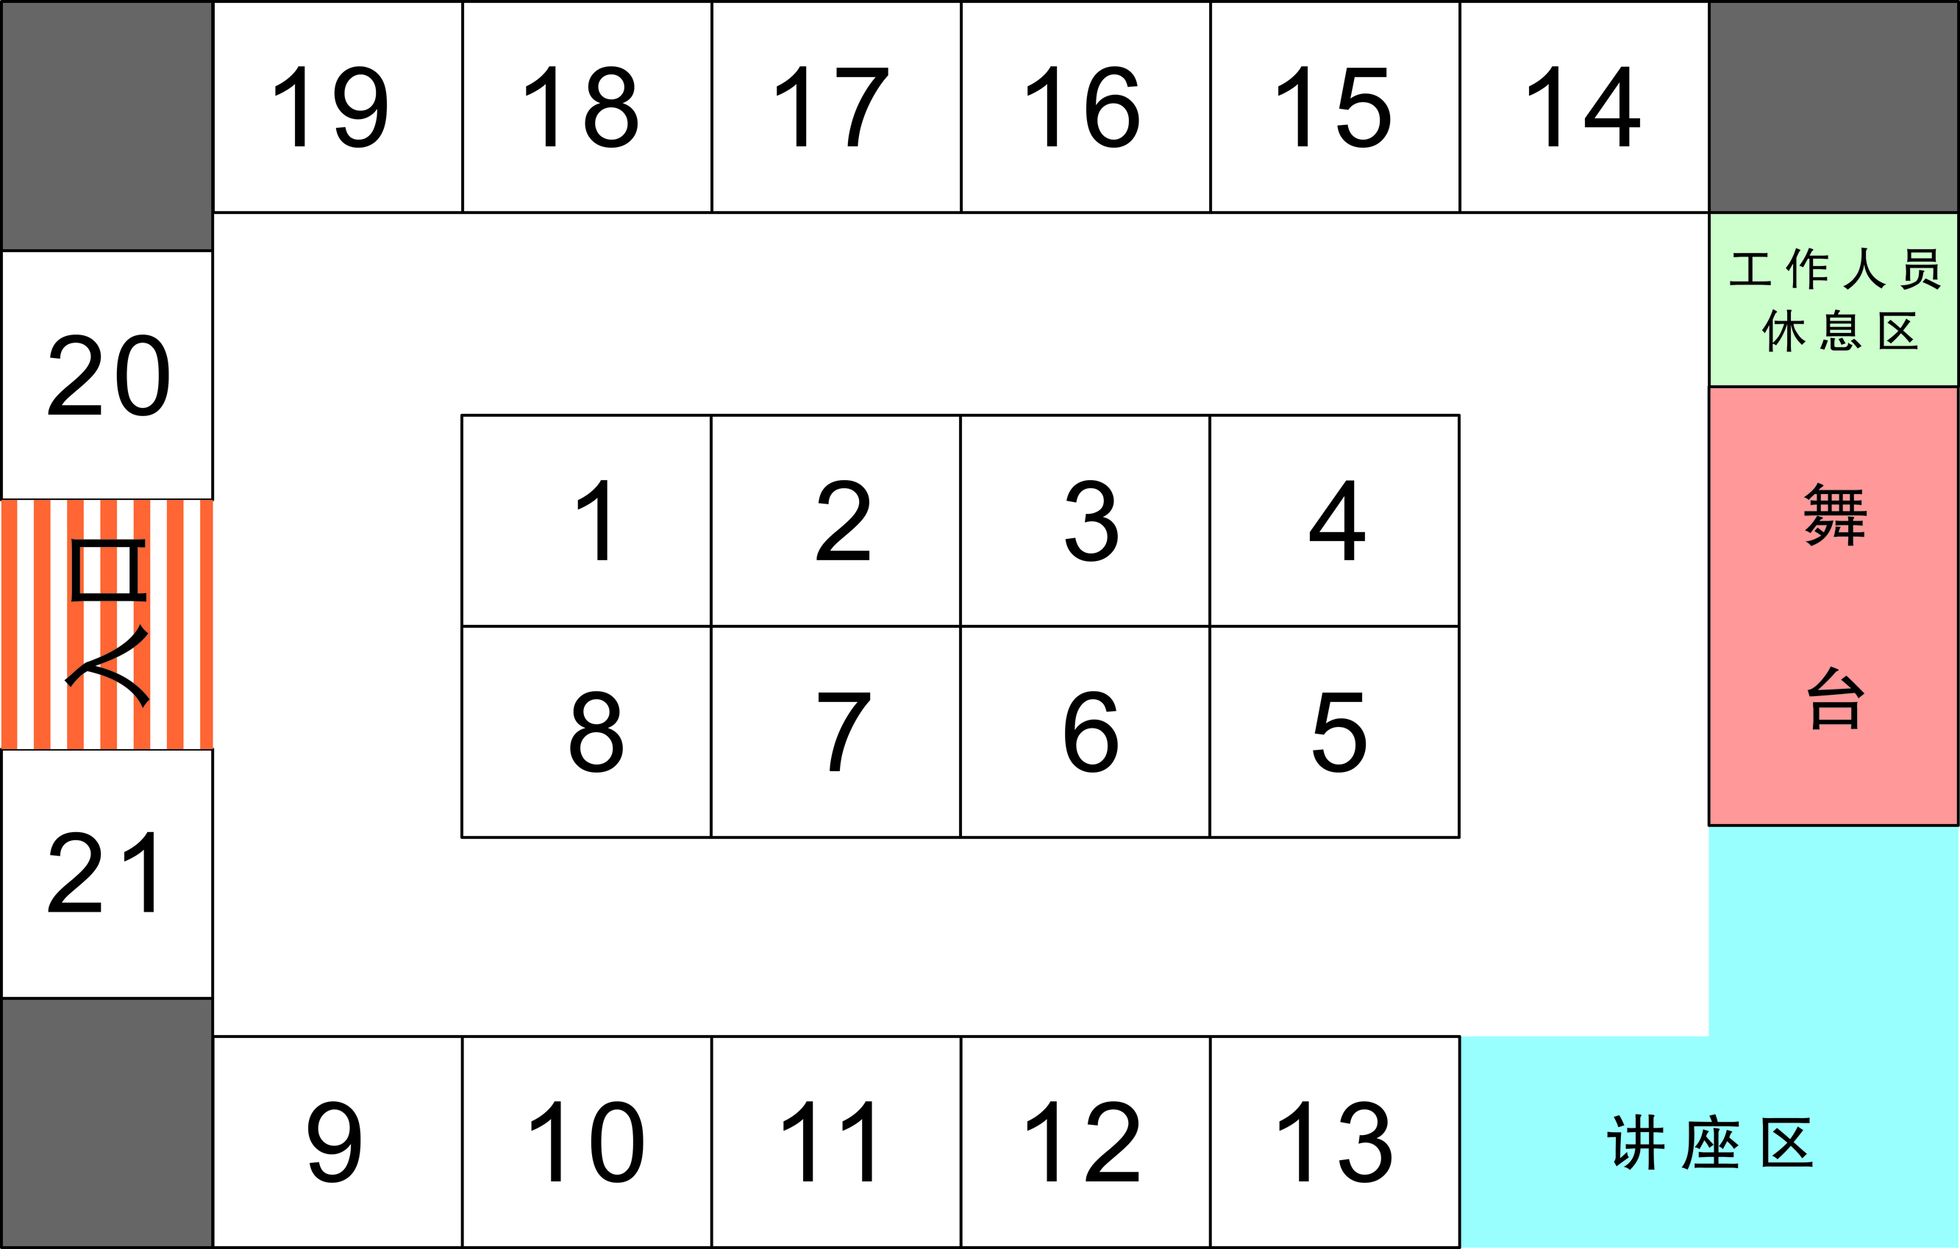
Llnfen Fushilong Hotel (Booth map)
